BY ARVIND CHAURASIYA


Restaurant Expansion
Objective Observations

- What is the total no. of tables present in the data?
The given data of Zomato Restaurants Expansion has Two tables. Those are:
- Raw Data – This consists of all the important data such as restaurant name, restaurant id, city, country code etc.
- Country description – This has the country name with country code

- What is the total no. of attributes present in the data?

The data has a total of 22 attributes. Here the attributes refer to the columns in the sheets given in the dataset. Each attribute refers to the specific characteristics or the property the data stored.
- 21 Attributes in the Raw Data sheet. Those are:
RestaurantID, RestaurantName, CountryCode, City, Address, Locality, LocalityVerbose, Longitude, Lattitude, Cuisines, Currency, Has_Table_Booking, Has_Online_Delivery, Is_delivering_now, Switich_to_order_menu, Price_range, Votes, Averege_cost_for_two, Rating, Datekey_opening
- 1 Attribute in country description
CountryName
Note:
- Among all the attributes CountryCode plays a key role in helping in connecting two tables. It acts as a Primary Key in CountryDescription sheet and Foreign Key in RawData sheet.
- Count of attributes that are mentioned only include that are given in the dataset, new attributes that are created for the ease of analysis are not considered.

- How many categorical columns are there in the data?

Categorical and Numerical / Continuous Data are the part of any data set.

- Categorical Data represents distinct groups or categories in the dataset.
Numerical / Continuous Data refers to the numerical values that can take any value within a range.

- So, this Data set has 17 Categorical Columns. Those are:
RestaurantID, RestaurantName, CountryCode, City, Address, Locality, LocalityVerbose, Cuisines, Currency, Has_Table_Booking, Has_Online_delivery, Is_delivering_now, Switch_to_order_menu, Price_range, DateKey_Opening and CountryName.
- There are 5 Numerical / Continuous data column in the given dataset
Longitude, Lattitude, Votes, Averege_cost_for_two and Rating.

- The data consists of some inconsistent and missing values so ensure that the data used for further analysis is cleaned.

Data Inconsistency may happen due to human errors, system migration, synchronization issue between dataset etc…. It results in poor insights, reduced data integrity and compromised or biased decision making. To prevent these data cleaning is done.

- Given Data is checked for duplicate entries. No duplicate entries were found in the data.
- For ease of analysis CountryName is added as a new column in the RawData sheet with the help of VLOOKUP function of excel with exact match criteria.
After the extraction of the CountryName, it is pasted as value in the Country column in the RawData sheet.
- There are blanks cells in the given data. There are a total of 9 blanks in the column Cuisines. These are removed from the dataset as it does not affect the data vehemently.
- Datekey_opening column is modified and new column is created with name DateKey_Opening_Modified
- Additionally created Year, month using text functions
Year - LEFT(U2,FIND("_",U2,1)-1)
Month - MID(U2,(FIND("_",U2,1)+1),((FIND("_",U2,(FIND("_",U2,1)+1)))- (FIND("_",U2,1)+1))).
With the help of the above two columns DateKey_Opening_Modified is created with the using
DATE(year,month,day) and is pasted as value.
Quarter column is created using if else statement from newly created DateKey_Opening_Modified column.
- Tbl_currency_exchange is created in the country description column for the ease of calculation of transaction amount in a single currency mode rather than in a multiple currency mode.
- With the help of the above table new column average_cost_for_two_USD and average_cost_for_two_INR is created using VLOOKUP function.
=S2*VLOOKUP(D2,'country description'!$E$1:$G$16,3,0).

- Using the LookUp functions, fill up the countries in the original data using the country code.

Used VLOOKUP function of excel to create a new column “CountryName” in the RawData sheet extracting from CountryDescription sheet.
Here the CountryCode column in used as connecting column between two sheets.
We can say that CountryCode column acts as Primary Key in Country Description and as Foreign Key in RawData sheet.

VLOOKUP(C2,Country_desc,2,0)
Here,
    - C2 refers to the cell where the country code is present in the RawData sheet. It is used as lookup value.
    - Country_desc refers to the table in the Country Description sheet where country name exists. It is used as lookup array.
    - 2 refers to the second column i.e. CountryName in the table country_desc.
    - 0 refers to the exact match criteria.

- Create a table to represent the number of restaurants opened in each country

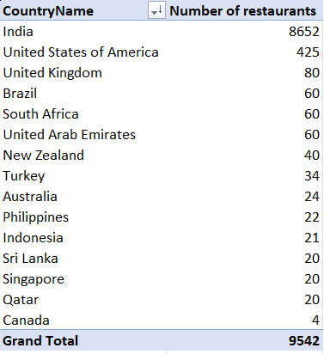
To get an overview on the total number of restaurants and number of restaurants in each country, a table is created with the help of Pivots which helps in aggregation of Total count of restaurants country wise.
Here we can observe that,
There are a total of 9542 restaurants across different parts of the world that are in associate with Zomato.
Over 91% of the restaurants are in India with 8652 restaurants.
Canada has least number of restaurants associated with Zomato with only 4 restaurants.

- Also, the management wants to look at the number of restaurants opened each year, so provide them with something here.

Further continuing the analysis over year on year regarding the total number of restaurants opened.

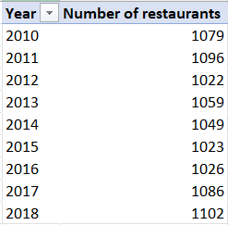
The average number of restaurants opened per year for the last 8 years is 1061.
However, 2018 has the most restaurants opened i.e. 1102 and 2012 has the least opening of restaurants with 1022.
There is an increase of 2.13% on restaurants opened from the year 2010 to 2018.

- What is the total number of restaurants in India in the price range of 4?

With over 91% of the restaurants opened in India, we shall analyse the count of restaurants with price range 4.

COUNTIFS('Raw Data'!D2:D9543,"India",'Raw Data'!Q2:Q9543,"4")

From the above formula it is observed that 388 restaurants are present in India with price range 4. It suggests that out of 8652 restaurants only 4.5% of the restaurants have high price range.

- What is the average number of voters for the restaurants in each country according to the data?

To get to know the success of the restaurant opened we have to consider attributes like votes and ratings received to the restaurants from the customers. We shall consider the voting in this as it shows the customer engagement in that country. We shall consider the average votes with regarding to each country
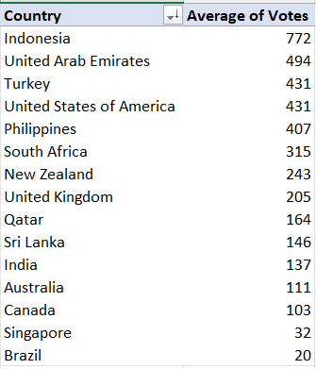

The average number of votes across the data is observed to be 157.
Indonesia has the highest average in terms of votes compared to any other country in the dataset with 772 votes, whereas Brazil has least with only 20 votes.

- Calculate the average rating for all the restaurants that have price_range < 4 and provide online delivery

Now coming to the rating, we shall analyse the average rating of the restaurant which has price range less than 4 and provides online delivery

AVERAGE(IF(('Raw Data'!Q:Q<4)*('Raw Data'!N:N="Yes"),'Raw Data'!U:U))

Above formula is used to calculate the average rating.
It is observed that 3.27 is the average rating of the restaurants for price range less than 4 and has online deliveries.

- Using Conditional formatting highlight the rows of restaurants that are located in the countries or cities that you’ve suggested to the management for opening new restaurants.

To highlight the restaurant name in the suggested country, conditional formatting is used to colour the specific restaurants in the country. On analysing the data, it is found that countries like Canada, Australia and Indonesia are suitable for opening restaurants. Reason for selecting the countries,
Canada
- Restaurants count is very low
- City vs restaurant count is also low
Australia
- Low city vs restaurant count
- Good average cost for two
Indonesia
- Low city vs restaurant count
- Good Average cost for two
Detailed explanation is provided in the subjective observations.
To highlight the suggested countries we use conditional formatting.
To apply conditional formatting,
  - Select the range to be highlighted and Click on Conditional Formatting in Home Tab on ribbon.
  - Navigate to New rule in the drop-down menu.
  - After clicking on new rule, go to “Use a formula to determine which cells to format”.
  - Select the condition (Canada, Australia, Indonesia), Criteria/Condition for Highlighting the country is =$D2=” Canada”. Where D2 Column represents the CountryName Column, and select type of format to be done.
  - Click on OK and Apply.
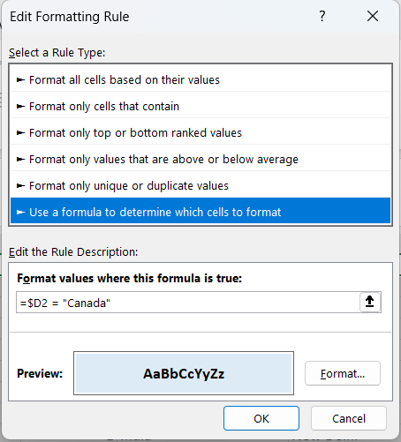
  - Repeat this for “Australia” and “Indonesia”
  - After applying the above conditions, the rows with suggested countries like “Canada”, “Australia” and “Indonesia” will be highlighted with its respective colours.
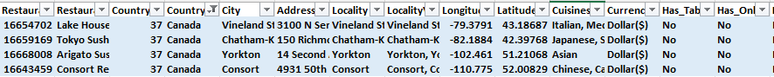
Records with Cananda:

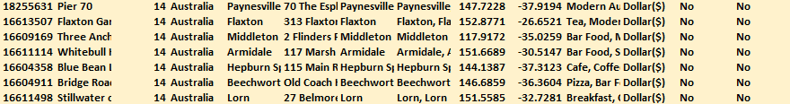
Records with Australia:

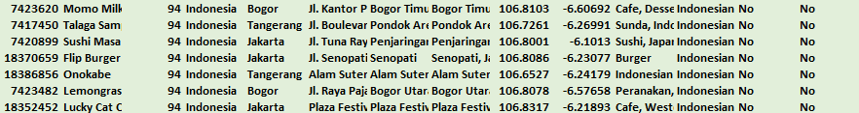
Records with Indonesia:

- Create a new customized price column that consists of the abbreviation/symbol of the currency along with the Average_cost_for_two value

Averege_cost_for_two in the data set is not properly formatted.
So, a new column is created as Average_cost_for_two_mod
where the money is concatenated with its respective currency
symbol.

CONCATENATE(MID(L2,FIND("(",L2,1)+1,FIND(")",L2,1)-(FIND("(",L2,1)+1))," ",S2)

Above text formula is used to concatenate the Averege_cost_for_two money with its respective currency symbol.

- How can you create an array formula in Excel or Google Sheets to count the number of restaurants listed that do not offer online delivery, are in the lowest price range, and have an average cost for two people less than or equal to 250 Indian Rupees?

An analysis is made on the data with the count of restaurant that has average cost for two is less than or equal to 250 Rs, do not have online delivery and on the lowest price range.

To make such analysis on multiple condition with filtering the data and then summing up together to get the count, SUMPRODUCT of Arrayformula is used.

SUMPRODUCT(('Raw Data'!AB2:AB9543<=250)*('Raw Data'!N2:N9543="No")*('Raw Data'!Q2:Q9543=1))

Total of 1691 restaurants have satisfied the above assumed conditions.

Subjective Observations:

- Suggest a few countries where the team can open newer restaurants with lesser competition. Which visualization/technique will you use here to justify the suggestions?

With over 9500 records in the data set it is important to take right decision regarding open of a new restaurant in a particular country or city where there are less competitors, has good returns in terms of money and easy to expand the restaurant chain in future.

On analysing various attributes given in the dataset few countries are suggest considering the following criteria,
  - Total restaurant count in a particular country is less than 60
  - Restaurant count to city ratio of a particular country is less than 18
  - Average rating is less than 3.7
  - Average cost for two is less than Rs.4000
Restaurant to City Ratio
Country vs Restaurant Count

Average rating
Restaurant vs AOV for 2

Insights:

- Canada has the least restaurant count.
- Turkey has the highest restaurant to city ratio and very affordable pricing.
- Australia has the highest rating of restaurants.
- India has the least rating.
- New Zealand has the most restaurant count.
- United states of America is quite expensive.

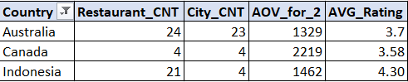

From the analysis made above, it is recommended to open the restaurants at Canada, Australia and Indonesia. Based on the addressable market, any of the mentioned country can be chosen since these countries have less competition and has huge potential in generating good returns on the money invested.

- Come up with the names of States and cities in the suggested countries suitable for opening restaurants.

Analysing with suitable data points regarding the state and the city, few suggestions are made regarding the opening of the new restaurant. A pivot table is created to justify the suggestion given above.

Most suitable locations are:
  - Australia – Flaxton, Paynesville, Montville
  - Canada - Chatham-Kent, Consort, Vineland Station, Yorkton
  - Indonesia – Tangerang
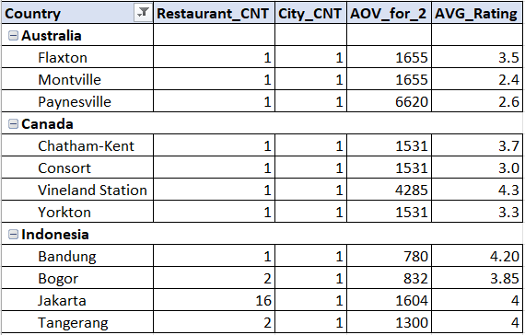

Reason for suggestion:
  - Australia
    - Its City to Restaurant count ratio is 1, which means there is only one restaurant for each city.
    - Its average order value for 2 is around 1350, but in some places like Flaxton and Montville its over 2000 and in Paynesville its around 6500
    - Though the country average rating is 3.7, in high order value city its below 2.5 which means there is a huge potential for good quality and tasty food
  - Canada
    - Its City to Restaurant count ratio is 1, which means there is only one restaurant for each city.
    - Its average order value for 2 is over 2200, but in places like Vineyard station its over 4500 with only one restaurant
    - Though the country average rating is 3.5, in some cities around 3 which indicates there is a huge demand for good quality and tasty food
  - Indonesia
    - Though its City to Restaurant count ratio is 5, which means there are 5 restaurants for each city, its majority of the restaurants i.e. with over 65% of the restaurants are in Jakarta rest other cities have around 2 restaurants per city.
    - Its average order value for 2 is around 1450, but in some place like Tangerang its around 1300 with satisfactory rating of 4, which means with good quality and better food there can be increase in AOV.

- According to the countries you suggested, what is the current quality regarding ratings for restaurants that are open there?

To get into the ratings for the restaurants suggested, a pivot table is created where the analysis can be made regarding quality of the restaurant.
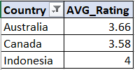
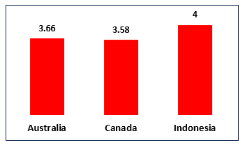

Australia and Canada’s rating are below 3.5 which means there is a need of improvement in the service and food at these restaurants, by proving good customer satisfaction there is a huge potential in these countries.
The pivot table analysis indicates that Indonesia currently demonstrates the highest restaurant quality with an average rating of 4.0, reflecting strong customer satisfaction and operational efficiency.
Australia (3.66) and Canada (3.58) show moderate performance levels. While not critically low, these ratings suggest opportunities for improvement in service quality, customer experience, and food consistency. Targeted operational enhancements in these countries could significantly elevate ratings, customer retention, and overall revenue growth.
- Also, what is the current expenditure on food in the suggested countries, so we can keep our financial expenditure in control?
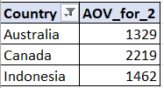
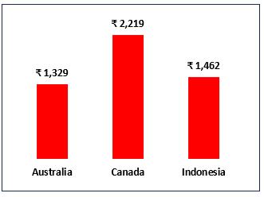
For maintaining the expenditures of the restaurants, analysis is made on average cost for 2 to forecast the financial expenditure.

The average cost for two in,
    - Australia is around Rs.1350 but in places like Flaxton and Montville its over Rs.2000 and in Paynesville its around Rs.6500.
    - Canada is over Rs.2200, but in places like Vineyard station its over Rs.4500 with only one restaurant
    - Indonesia is over Rs.1450.
According to the average cost for two in these countries, a forecast of expenditure has to be made so that the financial expenses are maintained efficiently.
The expenditure analysis indicates that Canada leads in average customer spending (₹2,219), positioning it as a premium and high-revenue market. Indonesia demonstrates balanced financial performance with moderate spending (₹1,462) and strong customer satisfaction, suggesting operational efficiency and pricing alignment. Australia records the lowest average order value (₹1,329), highlighting an opportunity to enhance revenue through upselling strategies and improved value perception.
To maintain financial control:
- Canada should focus on cost optimization and margin management.
- Indonesia should scale while maintaining service quality.
- Australia should implement revenue enhancement strategies to increase basket size.

- Come up with the names of restaurants from the recommended states that are our biggest competitors and also those that are rated in the lower brackets

Having Idea about the competitors and making analysis on them is a must when it comes to entering into the market. Competitor analysis helps us to set a benchmark in the performance, discover opportunities and Improve Strategy.

When it Comes to the competitors in the suggested Countries and cities with price range 1-2 and 2-3 are,
- Australia
  - Since there are only one restaurant in each city there is no much of competition when compared city wise, however in the suggested cities like Flaxton, Montville, Paynesville there are competitors like Flaxton Gardens, Poets Café and Pier 70 respectively.
  - Even though they have high AOV for 2 but their rating is very low. To stay ahead with the quality food and ambiance is sufficient.
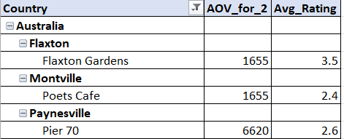

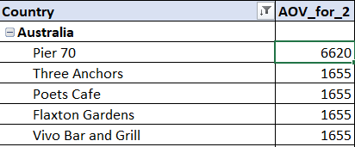
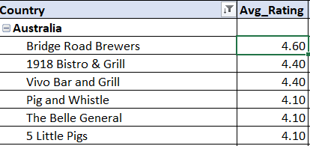
- However, when we compare the restaurants country wise,
Top 5 competitors w.r.t AOV_for_2
Top 5 competitors w.r.t Avg_rating

- Canada
  - Since there is only one restaurant in each city there is no much of competition when compared city wise, however in the suggested cities like Chatham Kent, Consort, Vineland Station, Yorkton there are competitors like Tokyo Sushi, Consort Restaurant, Lake House Restaurant, Arigato sushi respectively.
  - A very good competitor is Lake View Restaurant from Vineland Station which has a good AOV for 2 and rating, rest others have moderate AOV for 2 and below par rating
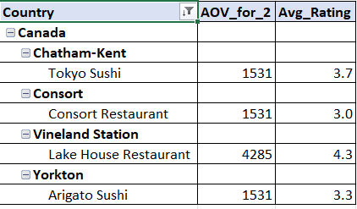

- Indonesia
  - Most of the restaurants are situated in Jakarta, Indonesia. So, at the remaining location there is no much of restaurants. In the suggested city Tangerang “Talanga Sampireun” has moderate AOV for 2 and high rating, where as Onokabe has healthy AOV for 2 and satisfactory rating.
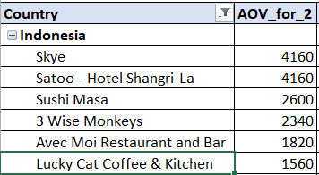
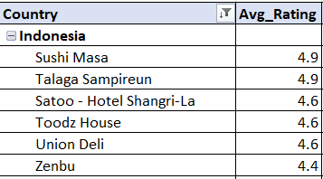
Top 5 competitors w.r.t AOV_for_2
Top 5 competitors w.r.t Avg_rating

- Which cuisines should we focus on in the newer restaurants to get better feedback? Does the choice of cuisines affect the restaurant ratings?

A restaurants success majorly lies upon the food that is served to the customer. The data clearly reflects that cuisine popularity varies across different countries, which in turn is essential to identify the best choice of cuisine for the recommended countries.
This analysis utilizes a Pivot table, taking into account the popularity of cuisines in the recommended region while also factoring in globally favoured cuisine types for a more comprehensive perspective.

Suggestion for the recommended countries,
- Australia
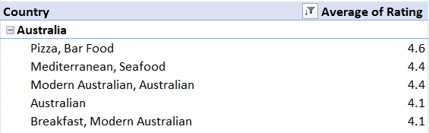

By analysing the average ratings, the top five most popular cuisines in Austria - Pizza, Bar Food, Mediterranean, Seafood, and Modern Australian are identified as key culinary preferences. To introduce more variety within similar cuisine types, we also explore globally popular cuisines that align with these, providing a broader perspective on food trends
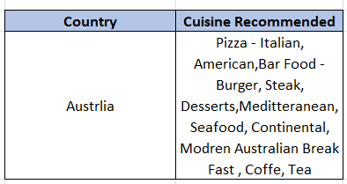

- Canada
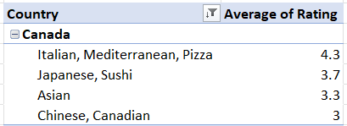

Top Cuisines that are popular in Canada are Pizza, Japanese, Sushi, Asian, Chinese. To introduce more variety within similar cuisine types, we also explore globally popular cuisines that align with these, providing a broader perspective on food trends.
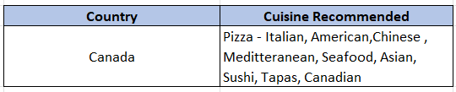

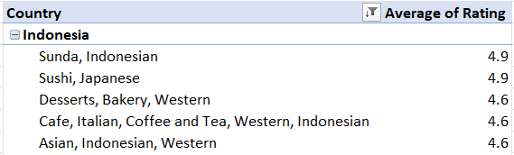
- Indonesia

By analysing the average ratings, the top five most popular cuisines in Indonesia Sunda, Indonesian, Sushi, Japanese, Desserts, Bakery, Coffee, Italian, Tea, Asian are identified as key culinary preferences. To introduce more variety within similar cuisine types, we also explore globally popular cuisines that align with these, providing a broader perspective on food trends
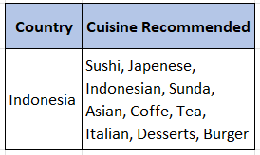

Incorporating the recommended cuisines tailored to each country will greatly enhance customer feedback and restaurant ratings, while also driving significant revenue growth.

- According to our current data, should we go for online delivery and table booking? Does that affect the customer’s ratings?

A pivot table was used to analyse how ratings are influenced by online delivery and table bookings, assessing whether these factors have a significant impact.
The following pivot table presents a breakdown of restaurants based on whether they offer table booking or not
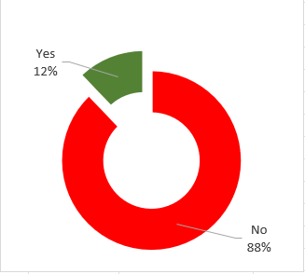
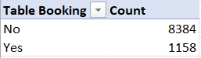
This Shows over 88% of the restaurants do not offer table bookings at the restaurant.
Restaurants with table booking facility

The following pivot table presents a breakdown of restaurants based on whether they offer online delivery or not

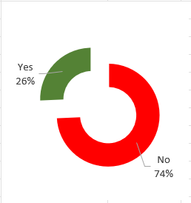
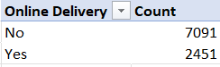
This Shows over 74% of the restaurants do not offer online delivery

The following data illustrates the influence of online delivery and table bookings on restaurant ratings.
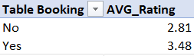
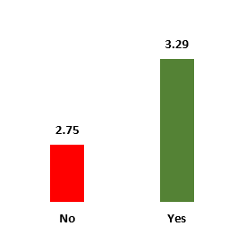
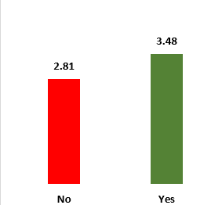
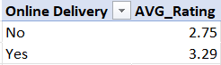
Online Delivery vs AVG_rating
Table _booking vs AVG_rating

The graphs above indicate that, although only a small percentage of restaurants offer online delivery (26%) and table booking (12%), these establishments tend to have significantly higher ratings compared to those that do not. Therefore, incorporating online delivery and table booking options is recommended and has impact on customer ratings and overall restaurant performance.

Recommendation:
Since recommended countries like Australia, Canada, and Indonesia currently do not offer online delivery or table booking feature integrating this service could be a key strategy to enhance restaurant ratings and customer satisfaction. Providing a seamless delivery and reservation system would likely improve the convenience and establish a sense of reliability among customers, ultimately leading to higher engagement and better reviews.

- Should the team keep the rate of cuisines higher? Will that affect the feedback? According to our data are the rates of cuisines and ratings, correlated?
Determining the appropriate pricing for a cuisine plays a crucial role in customer satisfaction and feedback. To facilitate analysis, a pivot table has been created to examine the provided data, specifically focusing on the Average cost of 2 of the cuisine and the average rating it has received.

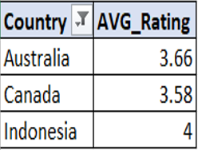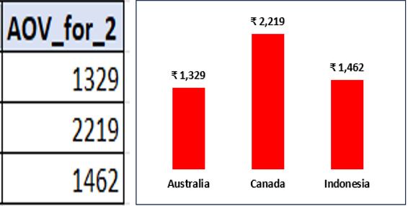

The calculated correlation between average rating and average order value is 0.18, indicating a very weak positive relationship. This suggests that customer expenditure is not strongly influenced by restaurant ratings alone. Other external factors such as pricing strategy, customer income levels, and market positioning play a more significant role in determining spending behavior. This is even confirmed with the formula to check the correlation between two ranges.=CORREL('Raw Data'!AB2:AB9543,'Raw Data'!U2:U9543)= 0.182651338
Here, A column refers to Average cost for 2 and B column refers to AVG_rating.

The team should not significantly increase cuisine prices at this stage. The weak positive correlation (0.18) between expenditure and ratings indicates that higher pricing does not strongly influence customer feedback. Instead, feedback is more dependent on service quality, food consistency, and perceived value. Any price increase should be accompanied by improvements in customer experience to avoid negatively impacting ratings.

- What is the distribution of the number of restaurants of different price ranges in all the countries?

A pivot table is utilized to analyse the distribution of restaurants across different price ranges, providing precise insights into this aspect. This approach ensures a clear and structured understanding of how restaurant numbers vary based on pricing categories.
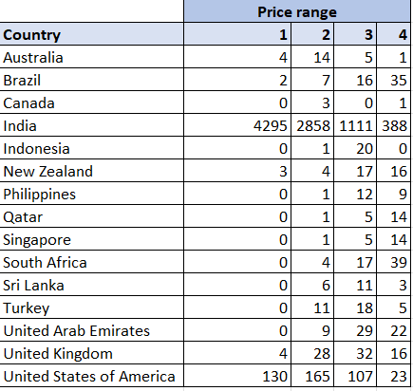

Conditional formatting is applied to enhance the visualization of percentage values in the table, making the data more interpretable and impactful.
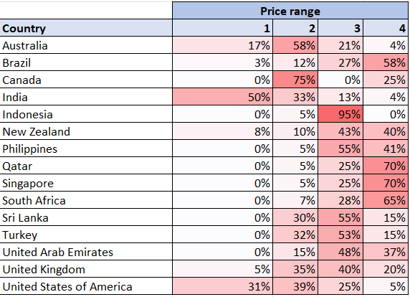

Excluding India and the United States, most countries have a concentration of restaurants within the price range of 3 and 4. This distribution aligns with the observed correlation between pricing and average ratings in these categories, further reinforcing the impact of pricing on customer perceptions.

- Explain your approach in brief for suggesting countries/cities in order to open new restaurants, if the objective and subjective questions would have not been given to assist you

Approach
- Understanding Business Requirements: Define key performance indicators (KPIs) based on the business objectives and expectations.
- Exploring Data Structure: Examine the provided datasets, including table relationships and attribute significance.
- Data Cleaning & Preparation: Identify and resolve inconsistencies such as duplicates and null values to ensure accurate analysis.
- Data Enhancement: Create additional columns if needed to streamline analysis and improve insights.
- Dynamic Data Summarization: Utilize pivot tables to generate country-wise summaries and facilitate interactive analysis.
- Visualizing Insights: Develop charts for better comprehension of key observations and trends.
- Restaurant Affordability Classification: Establish a five-band price range to categorize restaurants based on affordability.
- Quarterly Performance Tracking: Analyse financial metrics to maintain cost efficiency and revenue optimization.
- Regional Cuisine Analysis: Evaluate the popularity and performance of various cuisines in different regions to inform menu decisions.
- Comprehensive Reporting: Design dashboards to present the analysis visually and effectively for decision-making.

